Assignment 11(Group B3)

Name : Mohit Manish Bhavsar
Roll No : 20U437
Div : 4

Problem Statement:
Locate dataset (e.g., sample_weather.txt) for working on weather data which reads the text input files and finds average for temperature, dew point and wind speed.

import pandas as pd
import numpy as np
import seaborn as sns
import matplotlib.pyplot as plt
from sklearn.linear_model import LinearRegression
from sklearn.model_selection import train_test_split
df = pd.read_csv("training_data_with_weather_info_week_1.csv")
df.head()
Id Province/State Country/Region Lat Long Date ConfirmedCases \
0 1 NaN Afghanistan 33.0 65.0 2020-01-22 0.0
1 2 NaN Afghanistan 33.0 65.0 2020-01-23 0.0
2 3 NaN Afghanistan 33.0 65.0 2020-01-24 0.0
3 4 NaN Afghanistan 33.0 65.0 2020-01-25 0.0
4 5 NaN Afghanistan 33.0 65.0 2020-01-26 0.0
Fatalities day_from_jan_first temp min max stp slp dewp \
0 0.0 22 42.6 33.6 54.9 999.9 1024.3 27.4
1 0.0 23 42.0 32.7 55.9 999.9 1020.8 22.8
2 0.0 24 40.1 36.9 43.2 999.9 1018.6 34.5
3 0.0 25 46.0 37.9 56.3 999.9 1018.0 37.8
4 0.0 26 42.8 36.1 53.1 999.9 1014.8 33.2
rh ah wdsp prcp fog
0 0.545709 0.186448 9.4 0.00 0
1 0.461259 0.163225 14.9 99.99 1
2 0.801794 0.325375 10.4 0.17 1
3 0.728175 0.214562 6.1 0.57 1
4 0.685513 0.231656 10.8 0.00 1
df.tail()
Id Province/State Country/Region Lat Long Date \
17887 26378 NaN Zambia -15.4167 28.2833 2020-03-20
17888 26379 NaN Zambia -15.4167 28.2833 2020-03-21
17889 26380 NaN Zambia -15.4167 28.2833 2020-03-22
17890 26381 NaN Zambia -15.4167 28.2833 2020-03-23
17891 26382 NaN Zambia -15.4167 28.2833 2020-03-24
ConfirmedCases Fatalities day_from_jan_first temp min max \
17887 2.0 0.0 80 70.6 62.6 81.9
17888 2.0 0.0 81 71.3 66.2 81.5
17889 3.0 0.0 82 72.1 67.1 80.4
17890 3.0 0.0 83 71.7 66.2 80.6
17891 3.0 0.0 84 72.6 60.3 84.2
stp slp dewp rh ah wdsp prcp fog
17887 999.9 NaN 62.8 0.761545 0.198068 6.0 0.00 0
17888 999.9 NaN 65.3 0.812047 0.212487 7.1 99.99 1
17889 999.9 NaN 66.7 0.829815 0.218712 5.0 99.99 1
17890 999.9 NaN 62.8 0.733343 0.192580 4.2 0.00 0
17891 999.9 NaN 62.0 0.691204 0.183033 6.4 0.00 1
df.shape
(17892, 20)
df.isnull().sum()
Id 0
Province/State 9702
Country/Region 0
Lat 0
Long 0
Date 0
ConfirmedCases 0
Fatalities 0
day_from_jan_first 0
temp 0
min 137
max 16
stp 0
slp 6947
dewp 618
rh 618
ah 618
wdsp 0
prcp 0
fog 0
dtype: int64
mean_dew = df['dewp'].mean()
medain_dew = df["dewp"].median()
print("mean",mean_dew)
print("median",medain_dew)
mean 42.35362973254584
median 40.8
df.describe(include="all")
Id Province/State Country/Region Lat \
count 17892.000000 8190 17892 17892.000000
unique NaN 128 163 NaN
top NaN Diamond Princess US NaN
freq NaN 126 3654 NaN
mean 13191.500000 NaN NaN 26.287693
std 7624.675152 NaN NaN 22.935092
min 1.000000 NaN NaN -41.454500
25% 6596.250000 NaN NaN 13.145425
50% 13191.500000 NaN NaN 32.985550
75% 19786.750000 NaN NaN 42.501575
max 26382.000000 NaN NaN 71.706900
Long Date ConfirmedCases Fatalities \
count 17892.000000 17892 17892.000000 17892.000000
unique NaN 63 NaN NaN
top NaN 2020-01-22 NaN NaN
freq NaN 284 NaN NaN
mean 4.766191 NaN 325.207523 11.974737
std 79.923261 NaN 3538.599684 174.346267
min -157.498300 NaN 0.000000 0.000000
25% -71.516375 NaN 0.000000 0.000000
50% 9.775000 NaN 0.000000 0.000000
75% 64.688975 NaN 10.000000 0.000000
max 174.886000 NaN 69176.000000 6820.000000
day_from_jan_first temp min max \
count 17892.00000 17892.000000 17755.000000 17876.000000
unique NaN NaN NaN NaN
top NaN NaN NaN NaN
freq NaN NaN NaN NaN
mean 53.00000 54.849313 45.630262 64.380191
std 18.18475 22.306125 22.900739 22.310919
min 22.00000 -27.200000 -45.400000 -23.800000
25% 37.00000 38.800000 30.200000 47.500000
50% 53.00000 53.900000 44.400000 64.800000
75% 69.00000 76.800000 67.500000 84.600000
max 84.00000 97.300000 88.200000 109.600000
stp slp dewp rh ah \
count 17892.000000 10945.000000 17274.000000 17274.000000 1.727400e+04
unique NaN NaN NaN NaN NaN
top NaN NaN NaN NaN NaN
freq NaN NaN NaN NaN NaN
mean 702.306416 1016.581023 42.353630 0.665443 inf
std 428.769343 8.490953 22.399517 0.191092 NaN
min 0.000000 968.900000 -33.100000 0.053782 -2.374315e+01
25% 20.700000 1011.300000 27.000000 0.560904 1.161556e-01
50% 976.600000 1016.000000 40.800000 0.704800 1.932966e-01
75% 999.900000 1021.600000 63.500000 0.801220 2.329961e-01
max 999.900000 1051.700000 81.100000 1.000000 inf
wdsp prcp fog
count 17892.000000 17892.000000 17892.000000
unique NaN NaN NaN
top NaN NaN NaN
freq NaN NaN NaN
mean 25.521104 7.826334 0.336631
std 136.295573 26.740543 0.472571
min 0.000000 0.000000 0.000000
25% 3.500000 0.000000 0.000000
50% 5.600000 0.000000 0.000000
75% 8.700000 0.030000 1.000000
max 999.900000 99.990000 1.000000
df.dtypes
Id int64
Province/State object
Country/Region object
Lat float64
Long float64
Date object
ConfirmedCases float64
Fatalities float64
day_from_jan_first int64
temp float64
min float64
max float64
stp float64
slp float64
dewp float64
rh float64
ah float64
wdsp float64
prcp float64
fog int64
dtype: object
new = pd.DataFrame()
new['dew_point']=df['dewp'].fillna(42.35)
new['dew_point'].isnull().sum()
0
new.head()
dew_point
0 27.4
1 22.8
2 34.5
3 37.8
4 33.2
new['temp'] = df['temp']
new['wind_speed'] = df['wdsp']
new.head()
dew_point temp wind_speed
0 27.4 42.6 9.4
1 22.8 42.0 14.9
2 34.5 40.1 10.4
3 37.8 46.0 6.1
4 33.2 42.8 10.8
mean_temp = new['temp'].mean()
median_temp = new['temp'].median()
print("mean temp:", mean_temp)
print("median temp:", median_temp)
mean temp: 54.849312541918245
median temp: 53.9
mean_windspeed = new['wind_speed'].mean()
median_windspeed = new['wind_speed'].median()
print("mean windspeed:", mean_windspeed)
print("median windspeed:", median_windspeed)
mean windspeed: 25.521104404203115
median windspeed: 5.6
df['Country/Region'].value_counts()
US 3654
China 2079
Canada 693
Australia 567
France 504
...
Greenland 63
Guadeloupe 63
Guam 63
Guatemala 63
Zambia 63
Name: Country/Region, Length: 163, dtype: int64
sns.pairplot(new,diag_kind='kde')
<seaborn.axisgrid.PairGrid at 0x27e0dde5430>
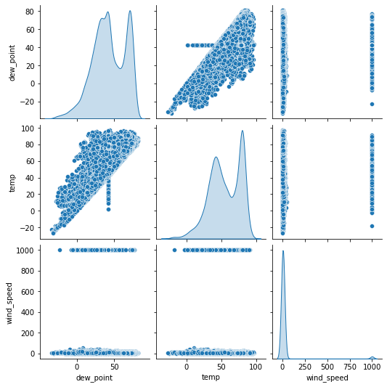
sns.pairplot(df,diag_kind='kde')
<seaborn.axisgrid.PairGrid at 0x27e0f3dc400>
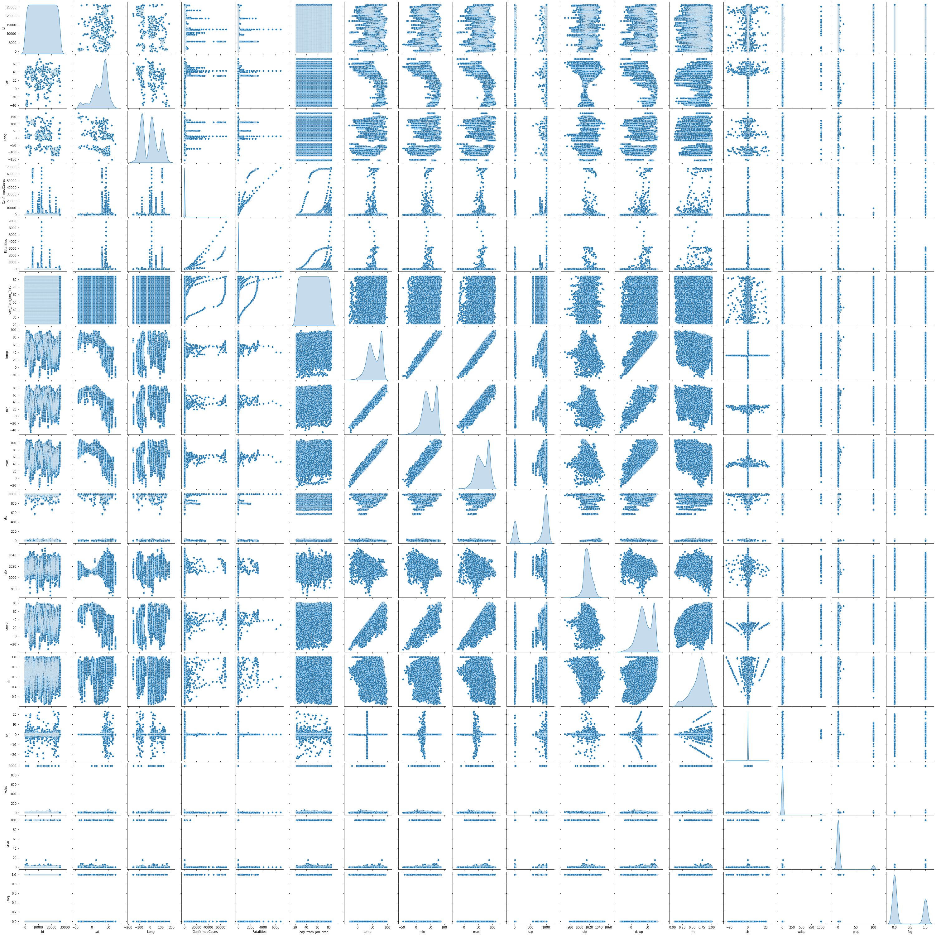
sns.scatterplot(x=new['dew_point'],y=new['temp'])
<AxesSubplot:xlabel='dew_point', ylabel='temp'>
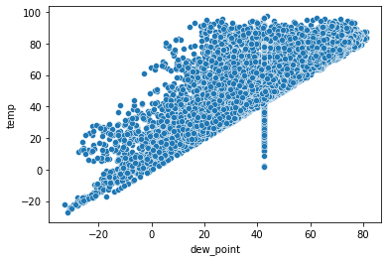
sns.scatterplot(x=new['wind_speed'],y=new['temp'])
<AxesSubplot:xlabel='wind_speed', ylabel='temp'>
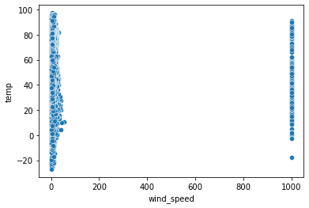
x = new[['dew_point','wind_speed']]
y = new['temp']
x_train,x_test,y_train,y_test = train_test_split(x,y,test_size = 0.25)
print(x_train.shape)
print(x_test.shape)
print(y_train.shape)
print(y_test.shape)
(13419, 2)
(4473, 2)
(13419,)
(4473,)
model = LinearRegression()
model.fit(x_train,y_train)
LinearRegression()
y_pred = model.predict(x_test)
print("Model Score :",model.score(x_test,y_test)*100)
Model Score : 77.41954752915808

